Foreign Travel
Insurance Policy Information
(CITY) is a member of a group purchase program for a variety of insurance policies, named the Authority for California Cities Excess Liability (ACCEL). One of the insurance policies purchased by ACCEL is Foreign Travel Insurance. If you experience issues when traveling on behalf of the City, please follow the below instructions for assistance. Please note that the named insured of the policy will be “ACCEL” instead of “(CITY)” when speaking with Chubb’s representatives. The policy number is PHFD01602512. YOU WILL NEED TO PROVIDE THE NAMED INSURED OF THE POLICY. THIS IS “ACCEL” or “AUTHORITY FOR CALIFORNIA CITIES EXCESS LIABILITY”. YOU WILL NOT BE ABLE TO USE THE NAME OF YOUR CITY.

Instructions to register on Chubb’s foreign travel app:

Step 1: Find and download Chubb Travel Smart app in app store.
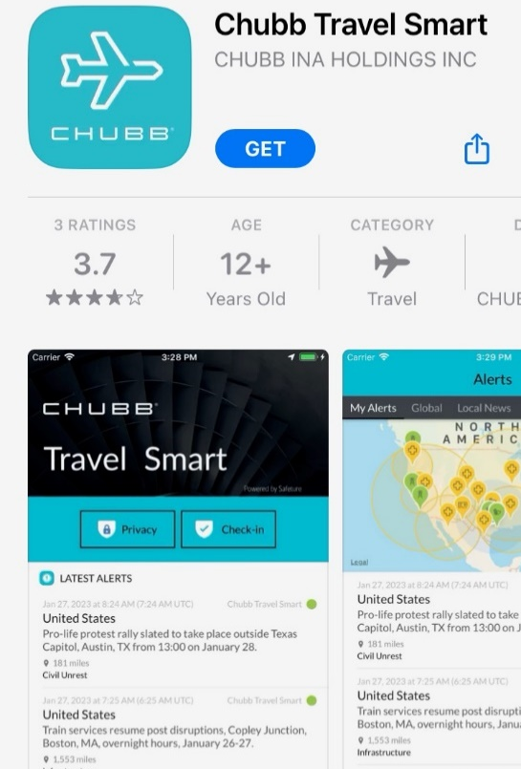

Step 2: Select “Sign Up” and follow instructions to register. They will request your name, phone number, and email.
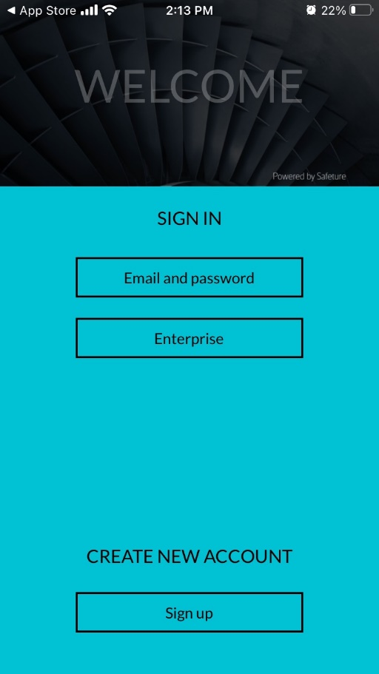

Step 3: Note the ACCEL policy number below. Please use this to register. Note that it is the number zero that appears in the below number, not the letter “O”.
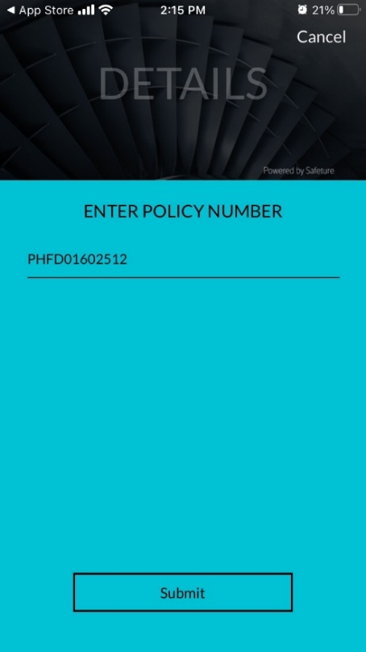
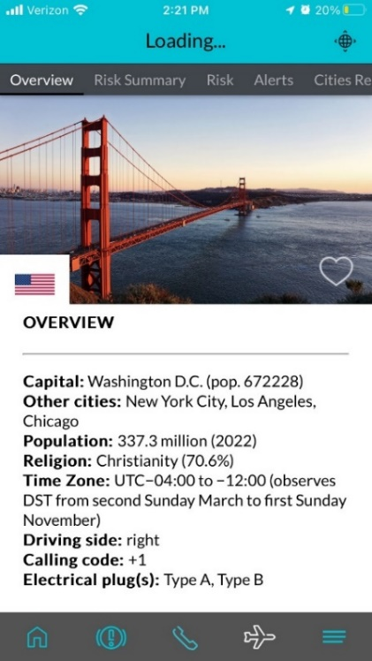
Step 4: Explore the bottom tabs of the app. These have helpful information on the country that you are visiting as well as current news stories and any developing situations in the region.

Step 5: In the event of emergency, select the middle tab to access the crisis hotlines.
